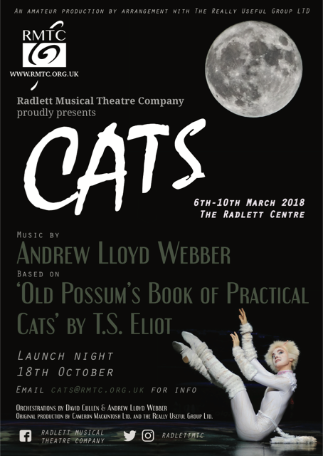





**Index**

* Introduction to Production Manager
* Introduction to the Creative Team
* Introduction to Cats
* A Synopsis of the production
* Musical Numbers
* A Character Breakdown
* Important Dates
* Audition Pieces
* Rehearsals
* Cats Audition Form
* Company Golden Rules

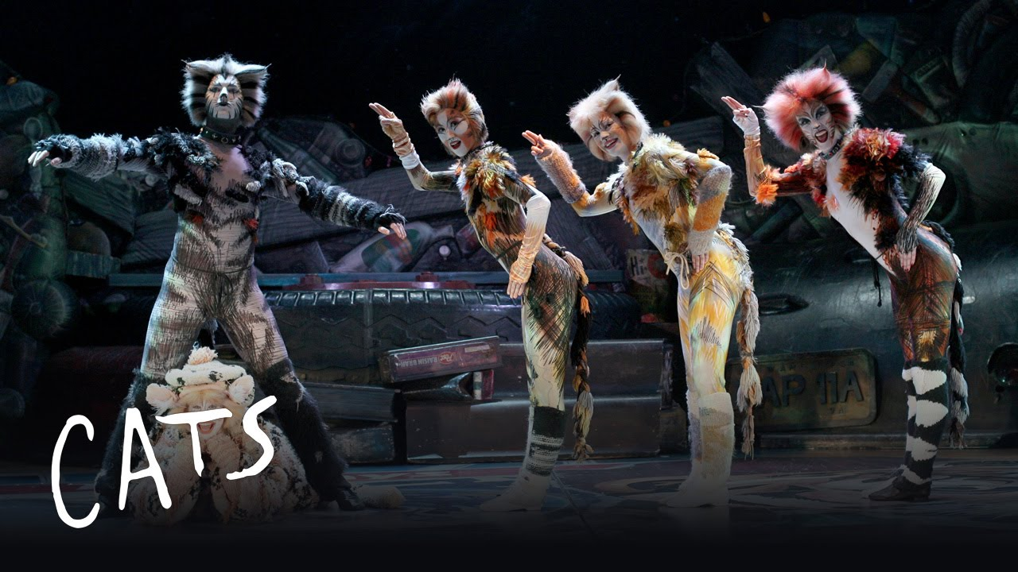

Introduction from Production Manager

Hello and welcome to our launch pack for RMTC’s spring production of the musical Cats. I am your production manager for this exciting show and cover every query no matter how big or small and I look forward to welcoming current, past and new members on board. We hope that this pack will provide you with as much information that you require and more for our forthcoming launch night on Wednesday 18th October 2017 and I look forward to working with you all.

Sharon Zaltszyrer Galatis

Production Manager

07775 500080

**Introduction to the Creatives**



**Jason Allen Lane** Director/Choreographer

I think it’s fair to say that I’m no stranger to RMTC having been on the creative team for the musicals *Company, Jesus Christ Superstar, Avenue Q, A Night at the Musicals, A Musical Night from Stage and Screen, Acorn Antiques, A Little Night Music* and most recently *The Producers* in which I had a cameo role as well as playing Mr Bundles in the musical *Annie* and Mr Lindquist in *A Little Night Music*.

To give you some background I started my training at the tender age of six years old with The Billie Barry Stage School and followed my professional full time theatre training with the National Performing Arts School, The College of Dance, Theatre Studies with Dry Ice Theatre company where I studied theatre directing, producing, costume, hair and makeup and dance followed by a Musical Theatre Degree with Laine Theatre Arts. I also worked a Red Coat for a number of years and was responsible for producing many cabaret summer and winter seasons in Blackpool.

I am currently choreographing the tour of “Cold Comfort Farm” which is an original musical theatre production based on the novel with the same title for Devon this Christmas. I work with many stage schools, colleges, production companies and musical societies in the UK as well as back in my home country Ireland.

When asked to direct and choreograph the musical Cats I was like a kid at Christmas as it’s truly like a dream come true from a creative and dance perspective and being one of the first musical companies to produce this musical which makes it all that little bit special. Over the past couple of months preparations have begun, I’ve been busy designing the art work for the show marketing material (poster, when we cast the part of Victoria we will replace the cat on our poster with our very own cast member), I’ve also been busy designing the set alongside Mark Wiggins and our stage management company (our Cats will need an oversized junk yard to play in!!), I’ve been researching costumiers and I’m very excited about the costumes that are being made for us, I’ve also been networking with London Theatre makeup school on working to get a make-up team together for our show week, and of course the direction and choreography as well as production meetings to ensure that we have the best crew on board to deliver an exceptional production. One set, one costume which makes it an easy one for the crew, but for the cast buckets of stamina is required for this production.

I am really excited about building my team of fur balls and bringing to life the wonderful characters created by T.S Elliot and cannot wait to get started. I would personally like to welcome both old and new faces to the company and wish you all the best at the auditions but remember to have fun and do your best and most importantly you need to be a team player.

I hope that you enjoy reading this document as much as we had putting it together and we hope that it answers as many questions that you may have. We look forward to seeing you on Wednesday 18th October at our launch night where we will be sharing our vision with you and also answering any questions regarding the audition process and any other questions that you may have.

**Susana Tierney** Musical Director

I think my first association with RMTC was playing in the pit for your production of ‘The Music Man’ in 2005, and more recently ‘Acorn Antiques’ so it is a great pleasure to join you as Musical Director for this very exciting production of ‘Cats’ and working for the first time with Jason and many familiar faces.

I started playing the piano at the age of 7, after begging my mother to let me give up the violin which she loved but I hated. After she agreed I took to piano like a duck to water and although I played other instruments piano was always my constant. I graduated from Trinity College of Music and then went on to assist the musical director in coaching the boys for *Oliver!* at the London Palladium, just to show my age this was the Sam Mendes production not the recent Jodie Prenger one. I now work within a music management agency looking after the world’s most acclaimed classical conductors, singers and instrumentalists which gives a nice balance to Musical Theatre. I have been MD locally for several shows including *Fiddler on the Roof*, *Annie Get Your Gun*, *Guys & Dolls*, *The Music Man*, *Me & My Girl, Kiss me Kate, Half a Sixpence, Children of Eden, Summer Holiday, Once Upon a Mattress, I Love You Because, Annie, Anything Goes, Little Shop of Horrors, Pirates of Penzance, Seussical, Jesus Christ Superstar and most recently Spamalot.* In fact I loved this one so much I am doing it again with Cassio at the Watford Palace between the 7th to 11th November – it will be lovely to see some of you there, but more importantly to see lots of faces at the launch night for ‘Cats’!

**Introduction to Cats**

*Cats* is a musical composed by [Andrew Lloyd Webber](https://en.wikipedia.org/wiki/Andrew_Lloyd_Webber), based on [*Old Possum's Book of Practical Cats*](https://en.wikipedia.org/wiki/Old_Possum%27s_Book_of_Practical_Cats) by [T. S. Eliot](https://en.wikipedia.org/wiki/T._S._Eliot), and produced by [Cameron Mackintosh](https://en.wikipedia.org/wiki/Cameron_Mackintosh). The musical tells the story of a tribe of cats called the Jellicles and the night they make what is known as "the Jellicle choice" and decide which cat will ascend to the [Heaviside Layer](https://en.wikipedia.org/wiki/Kennelly%E2%80%93Heaviside_layer#Cultural_impact) and come back to a new life. *Cats* introduced the [song standard](https://en.wikipedia.org/wiki/Standard_(music)) "[Memory](https://en.wikipedia.org/wiki/Memory_(song))". The first performance of *Cats* was in 1981.

The London production ran for 21 years and the Broadway production ran for 18 years, both setting new records. Actresses [Elaine Paige](https://en.wikipedia.org/wiki/Elaine_Paige) and [Betty Buckley](https://en.wikipedia.org/wiki/Betty_Buckley) became particularly associated with the musical. One actress, Marlene Danielle, performed in the Broadway production for its entire run (from 1982 until 2000).

As of 2016, *Cats* is the [fourth-longest-running show in Broadway history](https://en.wikipedia.org/wiki/List_of_the_longest-running_Broadway_shows), and was the longest running Broadway show in history from 1997 until 2006 when it was surpassed by [*The Phantom of the Opera*](https://en.wikipedia.org/wiki/The_Phantom_of_the_Opera_(1986_musical)). *Cats* is the [sixth-longest-running](https://en.wikipedia.org/wiki/List_of_the_longest-running_West_End_shows) West End musical. It has been performed around the world many times and has been translated into more than 20 languages. In 1998, *Cats* was turned into a [made-for-television film](https://en.wikipedia.org/wiki/Cats_(1998_film)).

Synopsis

**Act I — When Cats Are Maddened by the Midnight Dance**

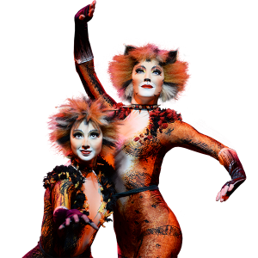The [Jellicle cats](https://en.wikipedia.org/wiki/Jellicle_cats) gather every year to make the "Jellicle Choice", and decide which cat will ascend to the Heaviside Layer and come back to a new life.

After the overture, the Cats gather on stage and explain the [Jellicle](https://en.wikipedia.org/wiki/Jellicle_cats) tribe and its purpose ("Jellicle Songs for Jellicle Cats"). The Cats (who break the [fourth wall](https://en.wikipedia.org/wiki/Fourth_wall) throughout the production) then notice that they are being watched by a man, and proceed to explain how the different Cats of the tribe are named ("The Naming of Cats"). This is followed by a dance from Victoria the White Cat, who performs a ballet which signals the beginning of the Jellicle Ball ("The Invitation to the Jellicle Ball"). Munkustrap (the wise second-in-command of the Jellicle tribe) explains that tonight, the Jellicle leader, Old Deuteronomy, will choose a cat to be reborn into a new life on the [Heaviside Layer](https://en.wikipedia.org/wiki/Heaviside_Layer).

[Munkustrap](https://en.wikipedia.org/wiki/Munkustrap) introduces [Jennyanydots](https://en.wikipedia.org/wiki/Jennyanydots) ("The Old Gumbie Cat"), a large tabby cat, who "sits and sits and sits and sits" every day, while (every night) she teaches the mice and cockroaches various activities. However, when Jennyanydots finishes her song, the number is interrupted, with the music changing suddenly, when the [Rum Tum Tugger](https://en.wikipedia.org/wiki/Rum_Tum_Tugger) makes an extravagant entrance ("The Rum Tum Tugger"). He is very fickle and unappeasable, "for he will do as he do do, and there's no doing anything about it".

As Rum Tum Tugger's song fades, a shabby old grey cat stumbles out and looks around (begging forgiveness of her sin she made before she was exiled from the tribe years ago); it is [Grizabella](https://en.wikipedia.org/wiki/Grizabella). Allthe Cats back away from her in fear and disgust and explain of her unfortunate state ("Grizabella: The Glamour Cat"). Grizabella leaves and the music changes to a cheerful upbeat number as [Bustopher Jones](https://en.wikipedia.org/wiki/Bustopher_Jones), a fat cat in "a coat of fastidious black", appears ("Bustopher Jones: The Cat About Town"). Bustopher Jones is among the elite of the cats, and visits prestigious [gentlemen's clubs](https://en.wikipedia.org/wiki/Gentlemen%27s_club). Suddenly, a loud crash then startles the tribe and the Cats run off the stage in fright. All of a sudden, hushed giggling sounds signal the entrance of [Mungojerrie and Rumpleteazer](https://en.wikipedia.org/wiki/Mungojerrie_and_Rumpleteazer), a pair of near-identical Cats. They are petty burglars, very mischievous, and they enjoy causing trouble for human families ("Mungojerrie and Rumpleteazer").

Finally, the Jellicle patriarch, [Old Deuteronomy](https://en.wikipedia.org/wiki/Old_Deuteronomy), appears ("Old Deuteronomy"). He is a large old Cat that "has lived many lives" and "buried nine wives (And more, I am tempted to say—ninety-nine)". He is the Cat who chooses which Jellicle Cat will go to the Heaviside Layer every year. After rejoicing to their leader's arrival, the Cats put on a play for Old Deuteronomy, called [*The Awefull Battle of the Pekes and the Pollicles*](https://en.wikipedia.org/wiki/The_Awefull_Battle_of_the_Pekes_and_the_Pollicles). It is a story about two dog tribes clashing in the street and subsequently being scared away by the Great [Rumpus Cat](https://en.wikipedia.org/wiki/Rumpus_Cat), a cat with flashing red eyes. After a moral from Old Deuteronomy about the destiny of Jellicle Cats and Pollicle Dogs, a second loud crash, presumably from Macavity, sends the alarmed Cats scurrying. Old Deuteronomy calls the Cats back and the main celebration begins ("The Jellicle Ball"), in which the cats sing and display their "Terpsichorean powers".

During the Ball, Grizabella reappears and tries to dance along, but her age and decrepit condition prevent her from doing so. Once again, she is shunned by the other Cats, but that does not stop her from singing a short version of "[Memory](https://en.wikipedia.org/wiki/Memory_(song))" while a guilty Old Deuteronomy looks on.

**Act II — Why Will the Summer Day Delay — When Will Time Flow Away?**

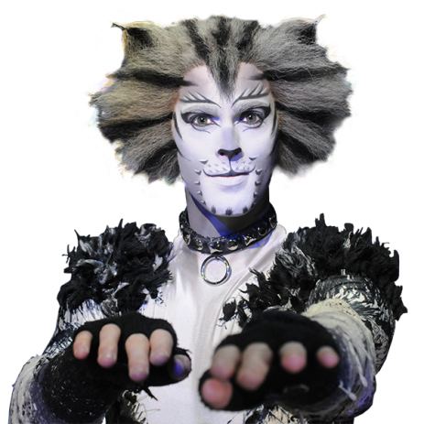After addressing the gathering by singing "[Memory](https://en.wikipedia.org/wiki/Memory_(Cats_song))", [Grizabella](https://en.wikipedia.org/wiki/Grizabella) is chosen to be reborn into a new Jellicle life.

After the Jellicle Ball, Old Deuteronomy complains about "what happiness is", referring to Grizabella, but the Cats do not believe him, so he sends the message to Jemima (or Sillabub, depending on the production), the youngest of all Jellicles, who sings it in simpler terms ("The Moments of Happiness"). [Gus](https://en.wikipedia.org/wiki/Gus_the_Theatre_Cat) — short for Asparagus — shuffles forward ("Gus: The Theatre Cat"). He was once a famous actor but is now old and "suffers from palsy which makes his paws shake." He is accompanied by [Jellylorum](https://en.wikipedia.org/wiki/Jellylorum), who tells of his exploits. Gus then remembers how he once played the infamous [Growltiger](https://en.wikipedia.org/wiki/Growltiger), the Terror of the Thames ("Growltiger's Last Stand"). He tells the story about the pirate's romance with his girlfriend, Lady Griddlebone, and how he was overtaken by the Siamese and forced to walk the plank to his death.

Back in the present, after Gus exits, [Skimbleshanks](https://en.wikipedia.org/wiki/Skimbleshanks) is seen sleeping in the corner ("Skimbleshanks: The Railway Cat"). He is the Cat who is unofficially in charge of the night train to Glasgow. Skimbleshanks is considered vital to the train, as without him "the train can't start". Within his song, a whole steam train engine is assembled out of objects in the junkyard: Various Cats spin wheels, hold up the structure, and light the headlights.

With a third crash and an evil laugh, the "most wanted" cat Macavity appears. He is a "master criminal" and is never found at the scene of the crime. Macavity's minions throw a net over Old Deuteronomy and capture him. As Munkustrap and his troops give chase to rescue Old Deuteronomy, [Demeter](https://en.wikipedia.org/wiki/Demeter_(cat)) and Bombalurina explain what they know about Macavity ("Macavity: The Mystery Cat"). When they are finished, Macavity returns disguised as Old Deuteronomy, but when Demeter blows his cover, Macavity ends up fighting with Munkustrap and Alonzo. Though the confused Macavity holds his own for a time, the rest of the tribe begin to gang up and surround him, but he shorts cut the stage lights as an attempt to escape in the confusion.

After the fight, an honest Rum Tum Tugger suggests that the Cats should find a local magician named [Mr. Mistoffelees](https://en.wikipedia.org/wiki/Mr._Mistoffelees) (also known as "the original conjuring cat") for help. ("Magical Mr. Mistoffelees"). According to Tugger, Mr. Mistoffelees is small and black and can perform feats of magic that no other Cat can do. Mr. Mistoffelees can also perform his own dance, which is often one of the most intricate and challenging dance solos in the show. As soon as he arrives just in time, the magical Cat restores the lights and brings back Old Deuteronomy, and all the Cats hail him as their emancipator. Now, the Jellicle Choice can be made.

After Old Deuteronomy sits down, Grizabella returns to the junkyard and he allows her to address the gathering. Her faded appearance and lonely disposition have little effect on her song ("Memory"). With acceptance and encouragement from Jemima and Victoria, her appeal succeeds and she is chosen to be the one to go to the Heaviside Layer and be reborn to a new Jellicle life ("Journey to the Heaviside Layer"). A large tire rises from the piles of junk, carrying Grizabella and Old Deuteronomy partway toward the sky; he then steps off so she can finish the journey on her own. Finally, Old Deuteronomy gives his closing speech to the human audience ("The Ad-dressing of Cats") and the show comes to a close.

**Musical Numbers**

|  |  |
| --- | --- |
| **Act I**   * "Overture" – Orchestra * "Prologue: Jellicle Songs for Jellicle Cats" – The Company * "The Naming of Cats" – The Company * "The Invitation to the Jellicle Ball" – Victoria, Quaxo, Munkustrap * "The Old Gumbie Cat" – Jennyanydots, Munkustrap, Bombalurina, Jellylorum, Demeter * "The Rum Tum Tugger" – Rum Tum Tugger and Company * "Grizabella: The Glamour Cat" – Grizabella, Demeter, Bombalurina * "Bustopher Jones: The Cat About Town" – Bustopher, Jennyanydots, Jellylorum, Bombalurina * "Mungojerrie and Rumpleteazer" – Mungojerrie, Rumpleteazer * "Old Deuteronomy" – Munkustrap, Rum Tum Tugger, Old Deuteronomy * "The Awefull Battle of The Pekes and the Pollicles" – Munkustrap, Rumpus Cat and Company * "The Song of the Jellicles" – The Company * "The Jellicle Ball" – Orchestra * "Grizabella: The Glamour Cat" (Reprise) – Jellylorum and Jemima * "Memory (Prelude)" – Grizabella | **Act II**   * "The Moments Of Happiness" – Old Deuteronomy, Jemima * "Gus: The Theatre Cat" – Asparagus, Jellylorum * "Growltiger's Last Stand" – Asparagus as Growltiger, Jellylorum as Griddlebone, and Company * "Gus: The Theatre Cat" (Reprise) – Asparagus * "Skimbleshanks: The Railway Cat" – Skimbleshanks and Company * "Macavity: The Mystery Cat" – Demeter, Bombalurina * "Macavity Fight" – Macavity, Munkustrap, Alonzo * "Mr. Mistoffelees" – Mr. Mistoffelees, Rum Tum Tugger, and Company * "Jellicle Choice"/"Daylight" – Munkustrap and Jemima * "[Memory](https://en.wikipedia.org/wiki/Memory_(song))" – Grizabella, Jemima * "The Journey to the Heaviside Layer" – The Company * "Finale: The Ad-Dressing of Cats" – Old Deuteronomy and Company |

**Act II**

* "The Moments Of Happiness" – Old Deuteronomy, Jemima
* "Gus: The Theatre Cat" – Asparagus, Jellylorum
* "Growltiger's Last Stand" – Asparagus as Growltiger, Jellylorum as Griddlebone, and Company
* "Gus: The Theatre Cat" (Reprise) – Asparagus
* "Skimbleshanks: The Railway Cat" – Skimbleshanks and Company
* "Macavity: The Mystery Cat" – Demeter, Bombalurina
* "Macavity Fight" – Macavity, Munkustrap, Alonzo
* "Mr. Mistoffelees" – Mr. Mistoffelees, Rum Tum Tugger, and Company
* "Jellicle Choice"/"Daylight" – Munkustrap and Jemima
* "[Memory](https://en.wikipedia.org/wiki/Memory_(song))" – Grizabella, Jemima
* "The Journey to the Heaviside Layer" – The Company
* "Finale: The Ad-Dressing of Cats" – Old Deuteronomy and Company

Character Breakdown

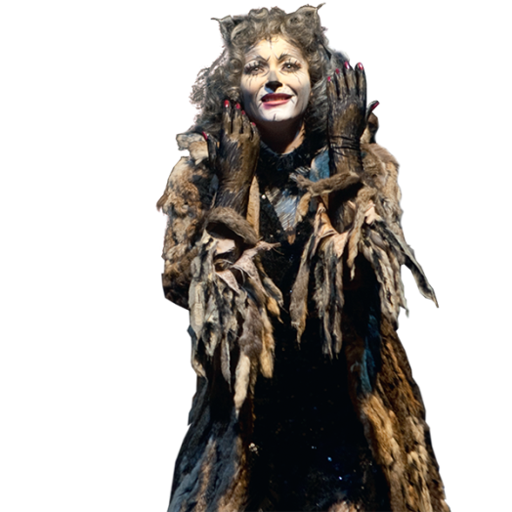**GRIZABELLA THE GLAMOUR CAT**

A former "glamour cat", ostracised by the Jellicles, who has lost her sparkle and now only wants to be accepted.

**GENDER:** [Female](http://stageagent.com/characters?g=Female)

**PART SIZE:** Lead

**DANCING:** [Non Dancer](http://stageagent.com/characters?dl=Non%20Dancer)

**VoICE:** [Alto](http://stageagent.com/characters?vp=Alto)

**HIGH NOTE:** E4 **LOW NOTE**: G3

**GUS THE THEATRE CAT**

An elderly actor, known as "the Theatre cat".

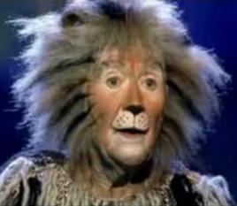**Gender:** [Male](http://stageagent.com/characters?g=Male)

**PART SIZE:** Supporting

**DANCING:** [Non Dancer](http://stageagent.com/characters?dl=Non%20Dancer)

**VOICE**: [Baritone](http://stageagent.com/characters?vp=Baritone), **HIGH NOTE**: A4 **LOW NOTE:** G2

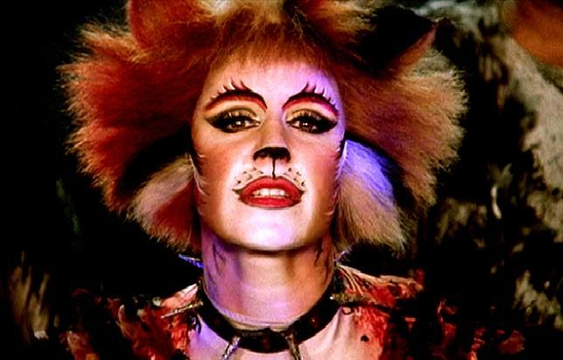**BOMBALURINA**

A red queen with a flame-colored pelt and an interest in the Rum Tum Tugger. She sings "Macavity" alongside Demeter and is 1 third of the "Gumbie trio" with Jellylorum and Demeter.

**GENDER:** [Female](http://stageagent.com/characters?g=Female)

**PART SIZE:** Supporting

**DANCING:** [Dancer](http://stageagent.com/characters?dl=Dancer)

**VOICE:** [Mezzo-Soprano](http://stageagent.com/characters?vp=Mezzo-Soprano), **HIGH NOTE**: A4 **LOW NOTE**: g3

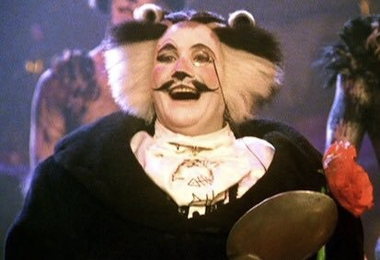**BUSTOPHER JONES**

A fat cat respected by all, as the upper-class "St. James's Street Cat." He is described as "the [Brummell](https://en.wikipedia.org/wiki/Beau_Brummell) of cats" due to his immaculate pelt, which resembles a tuxedo and spats.

**GENDER:** [Male](http://stageagent.com/characters?g=Male)

**PART SIZE:** Supporting

**DANCING:** [Non Dancer](http://stageagent.com/characters?dl=Non%20Dancer)

**VOICE:** [Baritone](http://stageagent.com/characters?vp=Baritone) **HIGH NOTE:** A4 **LOW NOTE**: G2

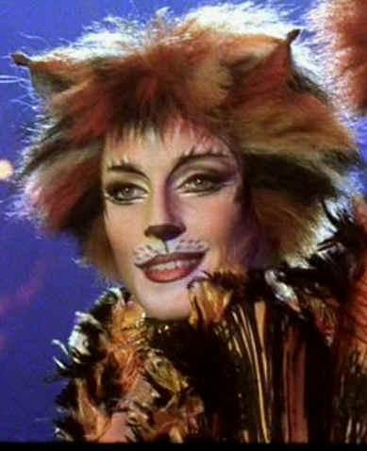

**DEMETER**

A skittish queen. She sings "Macavity" alongside Bombalurina and is 1 third of the "Gumbie trio" with Jellylorum and Bombalurina.

**GENDER:** [Female](http://stageagent.com/characters?g=Female)

**PART SIZE:** Supporting

**DaNCING:** [Dancer](http://stageagent.com/characters?dl=Dancer)

**VOICE:** [Mezzo-Soprano](http://stageagent.com/characters?vp=Mezzo-Soprano)

**HIGH NOTE**: D#5/Eb5 **LOW NOTE**: G3

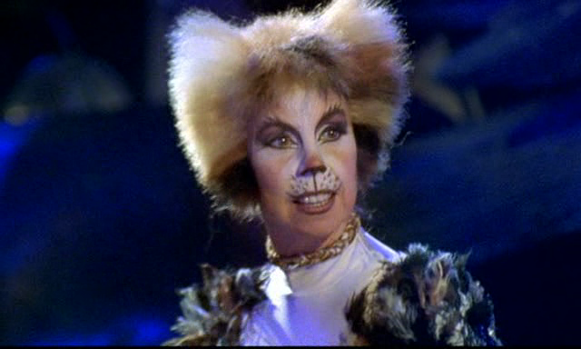**JELLYLORUM/GRIDLEBONE** A queen who watches out for the kittens, along with Jennyanydots. She sings "Gus: The Theatre Cat". Named after T. S. Eliot's own cat.

**GENDER:** [Female](http://stageagent.com/characters?g=Female)

**PART SIZE:** Supporting

**DANCING:** [Dancer](http://stageagent.com/characters?dl=Dancer)

**VOICE:** [Soprano](http://stageagent.com/characters?vp=Soprano)

**HIGH NOTE:** G5 **LOW NOTE:** G#3/Ab3

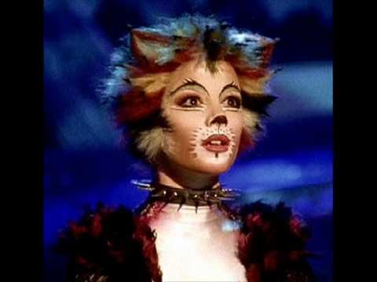**JEMIMA**

A kitten. She becomes the first cat to accept Grizabella when she sings alongside her in Memory (reprise) and sings a solo during The Moments of Happiness.

**GENDER:** [Female](http://stageagent.com/characters?g=Female)

**PART SIZE**: Supporting

**DANCING:** [Dancer](http://stageagent.com/characters?dl=Dancer)

**VOICE**: [Soprano](http://stageagent.com/characters?vp=Soprano)

**HIGH NOTE**: F5 **LOW NOTE**: G4

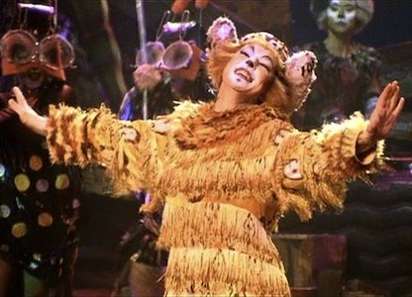

**JENNYANYDOTS** (The Old Gumbie Cat)

The old Gumbie cat. She sits all day and rules the mice and cockroaches at night, forcing them to undertake helpful functions and creative projects, to curb their naturally destructive habits.

**GENDER:** [Female](http://stageagent.com/characters?g=Female)

**PART SIZE:** Supporting

**DANCING:** [Dancer](http://stageagent.com/characters?dl=Dancer)

**VOICE:** [Mezzo-Soprano](http://stageagent.com/characters?vp=Mezzo-Soprano)

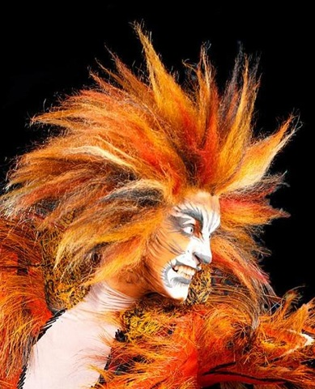**HIGH NOTE**: C#5/Db5 **LOW NOTE:** G3

**MACAVITY THE MYSTERY CAT**

A notorious criminal known as The Napoleon of Crime. The character is a literary [allusion](https://en.wikipedia.org/wiki/Allusion) to the [Sherlock Holmes](https://en.wikipedia.org/wiki/Sherlock_Holmes) character [Professor Moriarty](https://en.wikipedia.org/wiki/Professor_Moriarty).

**GENDER:** [Male](http://stageagent.com/characters?g=Male)

**PART SIZE:** Featured

**DANCING:** [Dancer](http://stageagent.com/characters?dl=Dancer)

**VOICE:** [Spoken](http://stageagent.com/characters?vp=Spoken)

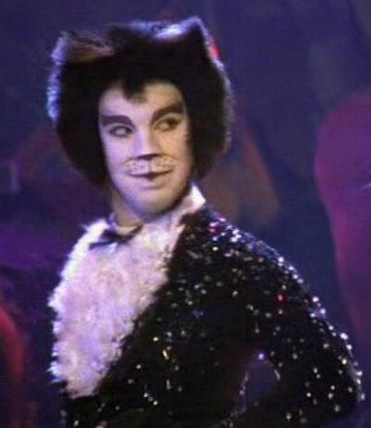

**Mr MISTOFFELEES**

A young tuxedo tom learning to control his magical powers. He is a featured dancer, performing a minimum of twenty-four [fouettés en tournant](https://en.wikipedia.org/wiki/Fouett%C3%A9" \o "Fouetté) during his number. Mistoffelees' chorus identity is sometimes known as Quaxo.

**GENDER**: [Male](http://stageagent.com/characters?g=Male)

**PART SIZE:** Supporting

**DANCING**: [Dancer](http://stageagent.com/characters?dl=Dancer)

**VOICE:** [Baritone](http://stageagent.com/characters?vp=Baritone) **HIGH NOTE**: D#4/Eb4 **LOW NOTE:** A2

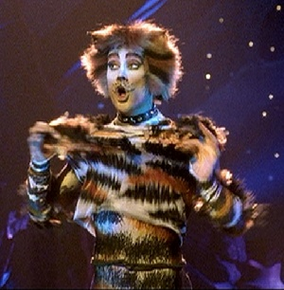**MUNGOJERRIE**

One-half of a notorious duo of cat-burglars, with Rumpleteazer.

**GENDER:** [Male](http://stageagent.com/characters?g=Male)

**PART SIZE:** Supporting

**DANCING:** [Dancer](http://stageagent.com/characters?dl=Dancer)

**VOICE:** [Baritone](http://stageagent.com/characters?vp=Baritone) **HIGH NOTE** G4 **LOW NOTE** B2

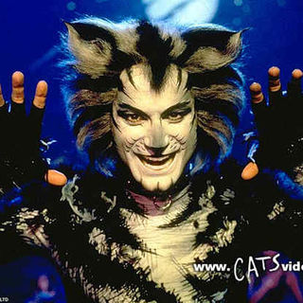**MUNKUSTRAP**

The show's main narrator. A tabby tomcat who is storyteller and protector of the Jellicle tribe. He is Old Deuteronomy's second-in-command.

**GENDER:** [Male](http://stageagent.com/characters?g=Male)

**PART SIZE**: Supporting

**DANCING:** [Dancer](http://stageagent.com/characters?dl=Dancer)

**VOICE:** [Baritone](http://stageagent.com/characters?vp=Baritone) **HIGH NOTE** G4 **LOW NOTE** B2

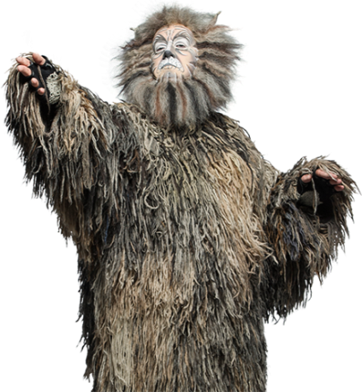**OLD DEUTERONOMY**

The elderly Jellicle Leader.

**GENDER:** [Male](http://stageagent.com/characters?g=Male)

**PART SIZE:** Supporting

**DANCING:** [Non Dancer](http://stageagent.com/characters?dl=Non%20Dancer)

**VOICE:** [Tenor](http://stageagent.com/characters?vp=Tenor)

**HIGH NOTE** G#4/Ab4 **LOW NOTE** C3

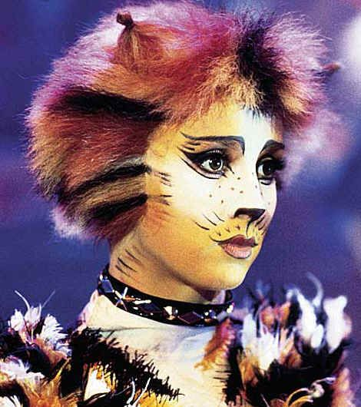

**RUMPLETEAZER**

One half of a notorious duo of cat-burglars, with Mungojerrie.

**GENDER:** [Female](http://stageagent.com/characters?g=Female)

**PART SIZE:** Supporting

**DANCING:** [Dancer](http://stageagent.com/characters?dl=Dancer)

**VOICE:** [Mezzo-Soprano](http://stageagent.com/characters?vp=Mezzo-Soprano)

**HIGH NOTE** D#5/Eb5 **LOW NOTE** G3

**VOCAL TECHNIQUE** Belting

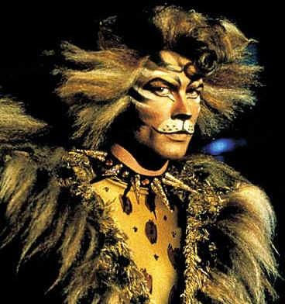**THE RUM TUM TUGGER**

A flashy cat. His temperament ranges from clownish to serious.

**GENDER**: [Male](http://stageagent.com/characters?g=Male)

**PART SIZE**: Supporting

**DaNCING**: [Mover](http://stageagent.com/characters?dl=Mover)

**VOICE**: [Baritone](http://stageagent.com/characters?vp=Baritone) **HIGH NOTE** F#4/Gb4 **LOW NOTE**

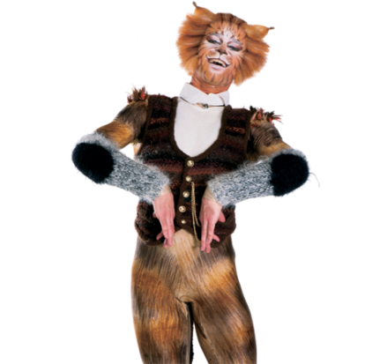

**SKIMBLESHANKS THE RAILWAY CAT**

The railway cat. An active orange tabby cat, who lives on the trains and acts as an unofficial chaperone to such an extent he is considered rather indispensable to the train and station employees.

**GENDER:** [Male](http://stageagent.com/characters?g=Male)

**PART SIZE:** Supporting

**DANCING:** [Dancer](http://stageagent.com/characters?dl=Dancer)

**VOICE:** bARITONE

**HIGH NOTE** G4 **LOW NOTE** G2

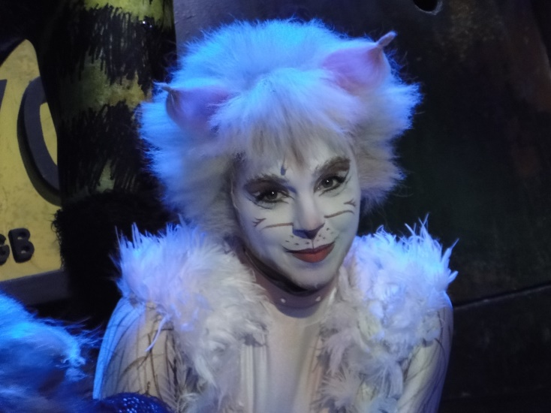

**VICTORIA**

A white cat. She is a featured dancer, opening with a solo in "Invitation to the Jellicle Ball" and is the first character to touch Grizabella.

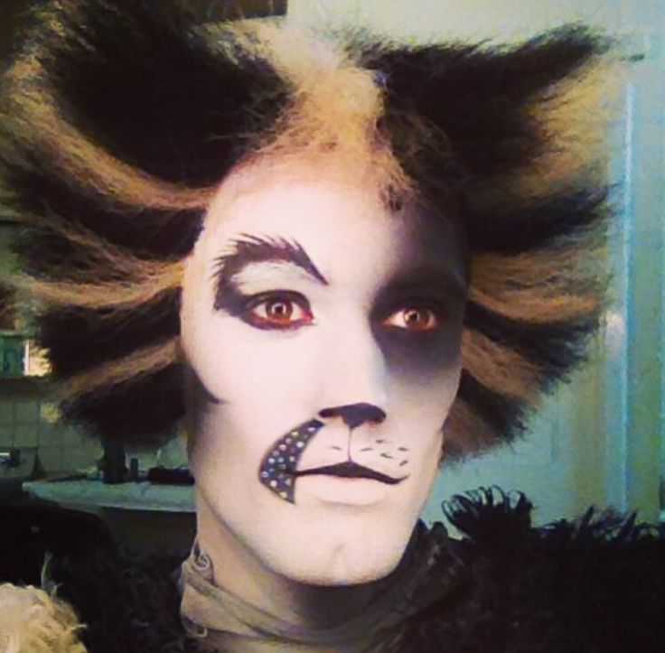**ALONZO**

A black and white/black and gold tom. Sometimes considered the third in seniority after Munkustrap as he also fights Macavity.

**GENDER:** [Male](http://stageagent.com/characters?g=Male)

**PART SIZE:** Featured

**DANCING:** [Dancer](http://stageagent.com/characters?dl=Dancer)

**VOICE:** [Baritone](http://stageagent.com/characters?vp=Baritone)

**Cats Dancers**

There are also a number of ensemble roles that dance and have lines to sing and are heavily featured throughout the production. To audition for this you need to attend the Dance Workshop, Dance Audition, Music Workshops and the main audition itself on Sunday 19th November. If you are unable to attend all of these dates please contact Sharon who will work with the creative team and advise the steps moving forward.

**Cats Chorus (Choir)**

When asked to direct/choreograph this production one thing sprung to Jason’s mind immediately and that was that not everyone would feel comfortable wearing a cat suit. So he wanted to create an addition to the cast to ensure that everyone was included and that was the part of the Cats Chorus who could vocally support the cats who are running up walls and singing through trees. The part of the Cats chorus will be auditioned and will be a featured part of the show. However please note that there will be no movement or cats costume and it is purely a vocal supporting role. One thing that RMTC are known for are its vocals and we think this will provide us with an opportunity to really utilise that skill.

**Kittens**

We will have two teams (Team Simba and Team Tigger) of five children in the show playing kittens maximum height 5 foot. They will perform in four numbers in the production. Auditions for the children’s roles will take place early January.

**Important Dates**

**The Launch Night Is Wednesday 18TH October 2017.**

**Time:** 19:45pm

**Venue:** St Johns Church, Gills Hill Lane, Radlett, Hertfordshire, WD7 8F, United Kingdom

Come along to the launch night of Andrew Lloyd Webber's "Cats"! Meet both Jason Lane; Director/Choreographer and Susana Tierney; Musical Director and fellow auditionee’s, get a feel for the show and characters and talk about audition material and ask any questions that you may have.

  
**New members auditions - 25th October**

Anyone who wishes to become a member of RMTC and be cast in the musical Cats needs to do a company audition to get into the company. The company audition consists of singing a song of your choice and delivering a piece of dialogue whether it be piece of script of your chosen or a poem in front of a few members of the committee.   
  
**Cats Dance workshop – Wednesday 1st November 2017**

Full Company needs to attend **apart** from the people wishing to play a member *of the Cats Chorus,* *Gus, Bustopher Jones, Old Deuteronomy*. We are aware that not everyone picks things up quickly or does well under the pressure of an audition so you will be thought a piece of choreography to take home and work on it for a week to then return the following week on 8th November to perform it at the best of your ability. This session will cover both Jazz and Tap (so please bring your tap shoes with you if you have them, please don’t worry if you do not tap shoes as not everyone will be tapping in this production).

**Cats Dance Audition- Wednesday 8th November 2017**

**\***(Please come dressed in tight fitted clothing if you are auditioning for one of the dancing roles, this is highlighted in the breakdown of character)

The main reason why the dance part of the audition process is being run this way is because a lot of the rehearsal period will be spent on doing your “homework” due to limited amount of time that we have for the rehearsal period, you will also be asked to perform any dance/acrobatics tricks that you can perform *(do let this put you off as the only one who really need to be particularly bendy are Mungojerrie and Rumpleteaser).*

*\*Please note that the only ones who* ***don’t*** *need to attend the dance audition are the people auditioning for: Gus, Bustopher Jones, Old Deuteronomy or a member of the cast chorus.*

*\*\*Please note that if you are unable to attend both of the dance Workshop and dance audition, the one that you* ***do*** *turn up to will be classified as your dance audition. ***Please do make us aware if this is in relation to you.*

**Music workshops – Wednesday 15th November & Thursday 16th November 2017**

Full Company anyone wishing to be part of the production whether they be a principle, dancer or cats chorus. Learn your audition material.

**Main auditions – Sunday 19th November 2017**

**Acting:**

You need to prepare either a poem or a verse of a song that you are familiar with to deliver the lyrics with the direction that you will be given on the day.

**Dance:**

Would have already been covered at the dance audition.

**Music:**

Chose Two songs:

* One song of the character that you are auditioning for.
* One contrasting song of your own choice to show off your vocal *ability (Please note that you may not get to sing the whole song so prepare a part of the song that you would like to perform).*

|  |  |
| --- | --- |
| **Audition Pieces**  **Cats Chorus, Dancers and Mr. Mistoffelees Music Audition Pieces:**   * Prologue: Jellicle Songs for Jellicle Cats   <https://www.youtube.com/watch?v=p3pAfc75myg>   * The Journey to the Heaviside Layer   <https://www.youtube.com/watch?v=pKH63cRJ3p4>  **Munkustrap and Jennyanydots Audition Piece**   * "The Old Gumbie Cat   <https://www.youtube.com/watch?v=dGQzKpqhDrs>  **The Rum Tum Tugger Audition piece:**   * The Rum Tum Tugger – Rum Tum Tugger   <https://www.youtube.com/watch?v=oHySvxR1fqg>  **Demeter, Bombalurina Audition Piece**:   * Macavity: The Mystery Cat   <https://www.youtube.com/watch?v=Ny-Lko5lO-0>  **Bustopher and Jennyanydots Audition Piece:**   * Bustopher Jones: The Cat About Town   <https://www.youtube.com/watch?v=mXWUz1RF2Dg>  **Mungojerrie, Rumpleteazer Audition Piece:** (Needs to have the Bonnie Langford voice)   * Mungojerrie and Rumpleteazer   <https://www.youtube.com/watch?v=861jN3mKE9Q>  **Grizabella Audition Piece:** | **Act II**   * "The Moments Of Happiness" – Old Deuteronomy, Jemima * "Gus: The Theatre Cat" – Asparagus, Jellylorum * "Growltiger's Last Stand" – Asparagus as Growltiger, Jellylorum as Griddlebone, and Company * "Gus: The Theatre Cat" (Reprise) – Asparagus * "Skimbleshanks: The Railway Cat" – Skimbleshanks and Company * "Macavity: The Mystery Cat" – Demeter, Bombalurina * "Macavity Fight" – Macavity, Munkustrap, Alonzo * "Mr. Mistoffelees" – Mr. Mistoffelees, Rum Tum Tugger, and Company * "Jellicle Choice"/"Daylight" – Munkustrap and Jemima * "[Memory](https://en.wikipedia.org/wiki/Memory_(song))" – Grizabella, Jemima * "The Journey to the Heaviside Layer" – The Company * "Finale: The Ad-Dressing of Cats" – Old Deuteronomy and Company |

* Memory

<https://www.youtube.com/watch?v=4-L6rEm0rnY>

* Grizabella: The Glamour Cat

<https://www.youtube.com/watch?v=xeh7yNLK4CM>

**Jemima Audition Piece:**

* The moment of Happiness (from 1:39 on the link below)

<https://www.youtube.com/watch?v=fTIiif7hIo4&list=RDfTIiif7hIo4>

**Asparagus and Jellylorum Audition Piece:**

* Gus: The Theatre Cat

<https://www.youtube.com/watch?v=HCFZgLWdjFI>

**Skimbleshanks Audition Piece:**

* Skimbleshanks: The Railway Cat

<https://www.youtube.com/watch?v=XEIiqhx3BSk>

**Old Deuteronomy Audition Piece:**

* Finale: The Ad-Dressing of Cats

<https://www.youtube.com/watch?v=0UaVMk4hXGo>

* The Moments Of Happiness

<https://www.youtube.com/watch?v=fTIiif7hIo4>

All subs must be paid before the auditions.  Anyone who hasn't paid their subs by then cannot audition for a part in the show.

**Please note:**

**Scripts will be given to successful auditionees once the show has been cast - to get this, you will need to pay a £25 deposit, which will be returned to you when the script is returned in good condition at the end of the show.**

**However, if you would like to take a script to practise for auditions, this deposit will need to be paid on the launch night. The deposit will then be returned to you at the end of the show if your audition successful, or after the audition process if you are not, or if you choose to not take part in the production.**

**Cheques would be preferable as they are easier to look after and return, but if this is not possible cash will also be accepted.**

It goes without saying that all auditionees should be able to sing in tune.

Try and learn it, but if you can’t then give us an educated reading (except in the dance audition). We will not cast a set of eyebrows peering over a piece of A4 and we will find it very difficult to cast someone who comes in without paper and gives us none of the words we asked for. Find a compromise. Give the best of yourself and if you have to read part of it then (make it good) and then learn the bits where physicality will be a big part of what you are performing. Auditions are horrid, but what comes after a successful one is FAB. We are all on the same side so just put as much effort into prep as you do into worrying, because only one of those will ever get you a part.

**Rehearsals**

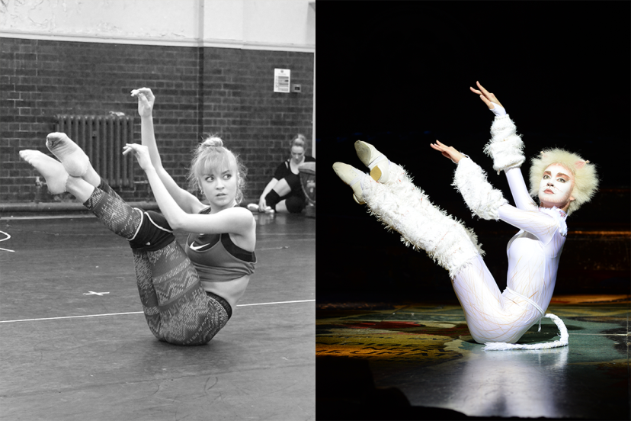All rehearsals will commence promptly please at **7.30 - 10.00pm** unless otherwise stated on rehearsal schedule. The company will rehearse Wednesdays **and** Thursdays. Rehearsals will be at **St Johns Church, Gills Hill Lane, Radlett. Any change to this will be notified via email and on Facebook.**

Please check the schedule carefully & arrive promptly, as we do not wish to call additional rehearsals from wasted late starts.

Sunday rehearsals are compulsory for everyone who is called. Dates and venues tbc.

Please note that attendance at rehearsals for which you are called is necessary and a register will be taken. We will try to schedule rehearsals around any known absences (eg holidays) but anyone who misses three other setting rehearsals risks being asked to leave the show unless the committee accepts that there are exceptional extenuating circumstances. Please note you must wear proper dance attire and dance footwear to all dance calls and ladies hair must be tied up at all times.

If you are unable to attend a rehearsal for which you are called, please contact the number listed below by 6.30pm (1pm Sundays) as this could affect your fellow cast members :-

**Production Manager:** Sharon Zaltszyre Galatis 07775 500080

**Membership Secretary:** Gilly Morris 07931 235000

If you are absent from a setting rehearsal please ask a fellow cast member to take notes for you and liaise together between rehearsals.

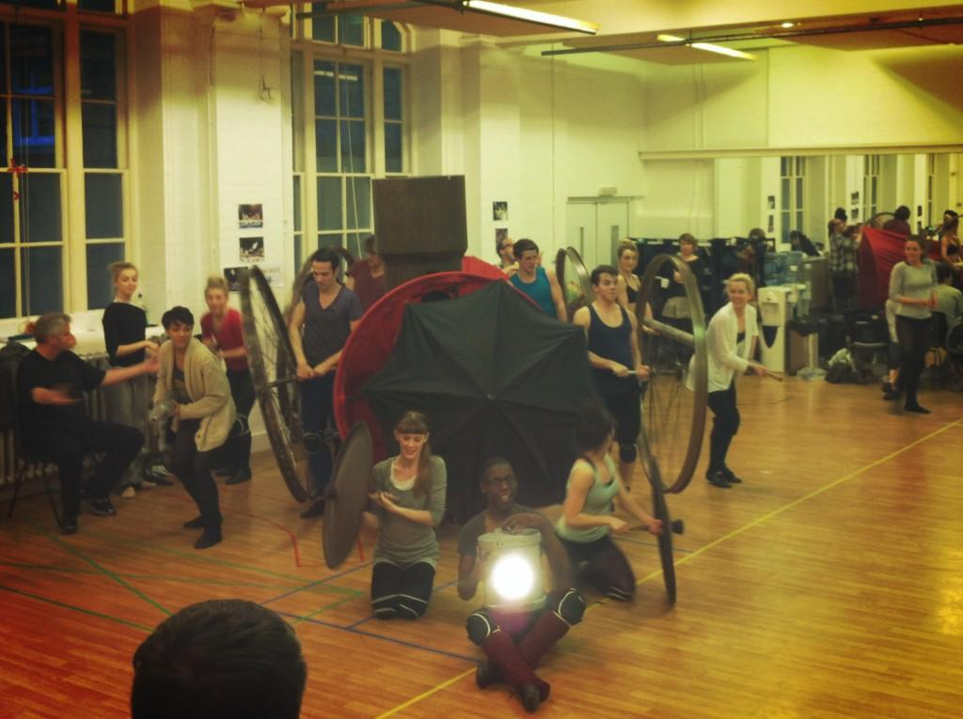

**PLEASE NOTE, EVERYONE IS REQUIRED TO FILL OUT AN AUDITION FORM SO THAT WE CAN BUILD OUR REHEARSAL SCHEDULE AROUND N/As.**

**\*If you are worried about N/Sa please bring to them to Sharon’s attention and the creative team alongside the committee will discuss and come back to you. In short do not put yourself off from being involved until you’ve discussed it with us as we may be able to work around it.**

**RADLETT MUSICAL THEATRE COMPANY**

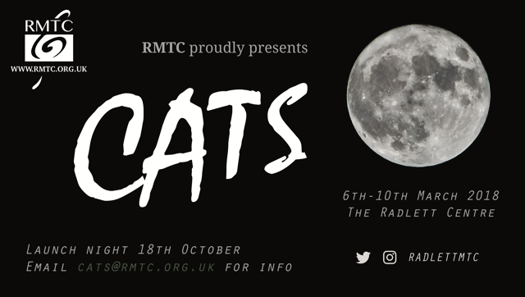

**Auditions**:

**Dance Workshop** Wednesday 1st November 2017, St. Johns Church, Radlett. 8.00pm

**Dance Audition**: Wednesday 8th November 2017, St. Johns Church, Radlett. 8.00pm

**Music Audition Prep**: Wednesday 15th November and Thursday 16th November 2017, St. Johns Church, Radlett. 8.00pm

**Main Auditions:** Sunday 19th November 2017, **United Free Church, Station Road, Radlett, WD7 8JX**

**Name:**..............................................................................

**Contact Details**: Home...................................................................

Mobile..................................................................

**Role auditioning for**:...............................................................................

**Other role(s) you are interested in:**

**Are you willing to be in the Cats chorus?**

**Known rehearsal dates you cannot attend:**

**Please return form to** [**auditions@rmtc.org.uk**](mailto:auditions@rmtc.org.uk) **or to Sharon by Wednesday 1st November 2017.**

***Radlett Musical Theatre Company***

***Golden Rules***

1. Company members are expected to **prioritise** the show and are not expected to miss more than three rehearsals during the setting period.
2. Company members are expected to attend **all** rehearsals in the **three week period prior to the show week**.
3. All absences must be notified to the Membership Secretary, Gilly Morris ASAP on
4. Mobile phones should be switched off or set to “silent” in the rehearsal room.
5. RMTC holds rehearsals in venues that have more than one room to enable the cast to socialise without disturbing the rehearsal. All cast members deserve the opportunity to rehearse without distraction.
6. Sunday Rehearsals are a standard part of the rehearsal process. Cast members should expect, and make themselves available for, all Sunday rehearsals if called.
7. Staging a show involves a huge amount of commitment from a great many people, not all of whom appear on stage. This is a team effort and everyone is required to “muck in” wherever required. This includes, but is not limited to, distributing leaflets, drying up coffee cups, tidying the rehearsal room and helping with get ins/get outs.

The Committee recognises that real life does get in the way from time to time, but regretfully must reserve the right to remove cast members in the event of poor attendance and lack of commitment to the show.